Learning How to Learn:

A Tasting Menu of Great Jewish Books for Lifelong Learning

with Rav Aubrey L. Glazer, PhD (Beth Abraham Synagogue)

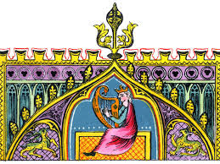

Learning How to Learn: A Tasting Menu of Great Jewish Books

DESCRIPTION: What makes Jewish learning so compelling while so seemingly unique? Jewish Thought touches on universal themes of spirituality, ethics, psychology, and society using a uniquely Jewish vocabulary drawn from Torah. Every historical era creatively uses Torah stories, metaphors, and teachings to advance our understanding. In this course we will become acquainted with these many facets of Torah as they appear, evolve and transmit wisdom across Jewish history. We will sample from a tasting menu of Great Books on the Jewish bookshelf, classic texts from Biblical Poetry, Narrative and Law as well as Talmud, Midrash, Philosophy, Medieval Torah commentary, Kabbalah, Hasidism, and Poetry. When we learn the multiple lenses of Jewish thought, we gain keys to vast resources of spiritual teaching that will create more colors to paint upon the canvas of our thinking for the journey of self and community. Consider this course a tasting menu of the banquet of Jewish learning that awaits you on the next step of your journey. Learning how to learn is an invitation to exploring the treasure troves of Great Books on the Jewish bookshelf.

INSTRUCTOR: Rav Aubrey L. Glazer, PhD (Beth Abraham Synagogue) rav@bethabrahamdayton.org
  - Meeting Time: Mondays @12 PM-1 PM (EST)
  - Course starts on August 15th, 2022

COURSE GOALS:
Competencies: Students who complete this course should be able to:
  - Summarize key genres within Jewish Thought
  - Identify and explain these approaches to foundational concepts relative to a text
  - Correctly use key genres within Jewish Thought to interpret texts
  - Consider how genres could respond to contemporary issues.
  - Cultivate understanding of how genres could respond to contemporary issues.
  - Cultivate a familiarity with genres of Jewish Thought

COURSE MATERIALS & RESOURCES:

REFER TO: the course syllabus below.

BUY or BORROW: Holtz, Barry W. Back to the Sources: Reading the Classic Jewish Texts. New York: Simon & Schuster, 1992. [BTTS] (A synagogue member has purchased a limited number of copies of this book. They are available on a first come/first served basis via request to bas@bethabrahamdayton.org.

https://www.abebooks.com/servlet/BookDetailsPL?bi=31081536201&searchurl=isbn%3D9780671454678%26n%3D100121503%26sortby%3D17&cm_sp=snippet-_-srp1-_-title1

BOOKMARK: Ecclesiastes (Qohelet) in all its 12 chapters available for each session in these formats:
  - JPS Tanakh bi-lingual (1906): https://www.mechon-mamre.org/p/pt/pt3101.htm
  - JPS Tanakh bi-lingual (1985) https://www.sefaria.org/Ecclesiastes?tab=contents

HEVRUTA: This is the name for the classic mode of dyadic learning. Each week we will be studying materials during class-time together interactively downloaded from the Beth Abraham website as PDFs. A link to the PDF pages will be sent to you.

ZOOM CLASSROOM: Our permanent class Zoom Room: https://tinyurl.com/mryfd93b
Meeting ID: 844 4077 4349
Passcode: 170087

WEEKLY CHALLENGE: CREATE A GLOSSARY
What is a good glossary?
Our weekly challenge is to share a good glossary definition of the salient term in Jewish Thought. This is an exercise in summation and precision. Read the assigned Back to the Sources section for the key term of the week, and then in your own words, in a total of 5 clear sentences, define and summarize the term, explaining or defining difficult or unusual words and expressions used in the text. Your task is to share with our group a helpful definition or explanation so that we understand what we are learning in Jewish Thought together.

SYLLABUS: LEARNING HOW TO LEARN

(1) Introduction: Learning How to Learn/Reading Jewish Texts
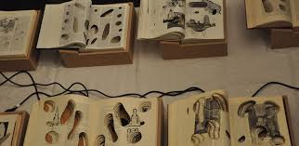
Reviewing Syllabus, Texts, Formats, Expectations, Backgrounds & Glossary Challenge
Reading Jewish Texts: Define Method of PaRD”eS = Peshat + Remez + Derash + Sod

Hevruta: *PDF1: “The Essence of Torah” (Zohar II: 176a-b)
Hevruta: *PDF2: "Tikkun" (Zohar III: 98a-98b)
Glossary: BTTS, Holtz, 11-30

(2) Bible 1: Biblical Poetry
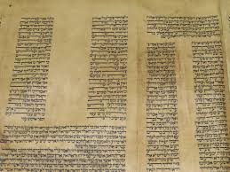
- Bible 1: Biblical Poetry— How can we define the peshat of "havel havalim" Qohelet 1:2?

Hevruta: *PDF1: Biblical Poetry in Qohelet 1:1, 1:2, 3:1-8
Hevruta: *PDF2: Poem by Richard Wilbur
Glossary: BTTS, Lichtenstein, 105-128
OPTIONAL ADVANCED: Alter, Art of Biblical Poetry (1985/2012) PDF

(3) Bible 2: Biblical Law
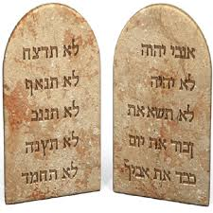
- Bible 2: Biblical Law —On tithing, charity and donations in Qohelet 11: 1

Hevruta: *PDF1: Teshuva of R. Shmuel Ariel;
Hevruta: *PDF2: Poem by Richard Wilbur
Glossary: BTTS, Greenstein, 83-104

(4) Bible 3: Biblical Narrative
4. Bible 3: Biblical Narrative—What is the story behind the darkness of death? How can we arrive at a coherent narrative if this narrative is to be understood allegorically? literally? or eschatologically?

Hevruta: Qohelet 12: 1-8
Glossary: BTTS, Rosenberg, 31-82

(5) Rabbinics (Talmud)
5. Rabbinics (Talmud)—Astrology, Divination & Mazel Tov?

Qohelet 11:1
Hevruta: *PDF1: bBaba Kama 2b;
Hevruta: *PDF2: bShabbat 53a
Glossary: BTTS, Goldenberg, 129-176

(6) Exegesis (Midrash)
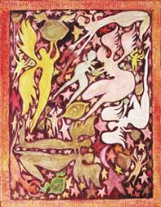
6.Exegesis (Midrash)— Being born… dying

Hevruta: Exegesis on Qohelet 3:2
Glossary: BTTS, Holtz, 177-212

(7). Medieval Commentary (Parshanut)
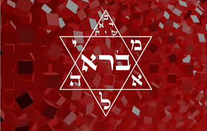
7. Medieval Commentary (Parshanut) — Politics, Power, & Patience

Hevruta: PDF: Parshanut on Qohelet 8:1, 10:4
Glossary: BTTS, Greenstein, 213-260

(8) Medieval Jewish Philosophy (Mahshevet Yisrael)
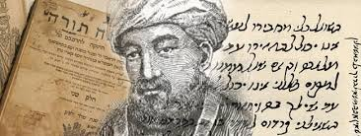
8. Medieval Jewish Philosophy (Mahshevet Yisrael)—Why light is only “sweet” to angels

Qohelet 11:7
Hevruta: *PDF1: Ibn Ezra on Qohelet 11:7
Hevruta: *PDF2: Rabbeinu Bahya ben Asher on Qohelet 11:7
Glossary: BTTS, Samuelson, 261-304

(9) Medieval Mysticism (Kabbalah): PaRD”eS
9. Medieval Mysticism (Kabbalah)—Upper & Lower Garden of Eden

Qohelet 4:2
Hevruta: *PDF Zohar III: 155b-156a
Glossary: BTTS, Fine, 305-360

(10) Pietism: Hasidism
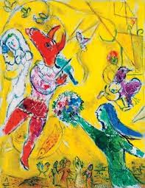
10. Pietism: Hasidism—Walking that Narrow Bridge Between Insanity & Exalted Consciousness

Qohelet 5:11, 10: 3
Hevruta: *PDF1: Reb Nachman, Liqqutai Moharan Tinyana 5:15
Hevruta: *PDF2: Reb Nachman of Bratzlav, “Tainted Grain”
Glossary: BTTS, Green, 361-402

11. Poetry (Shirah Siyyum)
11. Poetry & Song (Shirah Siyyum)— In-class evaluations: Next steps in Jewish Learning

Hevruta: *PDF, Sivan Har-Shafi, “The Sun Qohelet Knew Not”.

